**TASK # 1:**

**Create layered architecture style project for Generating Marksheet of a student. The system can be able to add new students 🡪 add scores of subjects(you can make 5 subjects of your choice) 🡪 Show list of students from database 🡪 Generate mark sheet for for particular student when click on it.**

**CODE:**

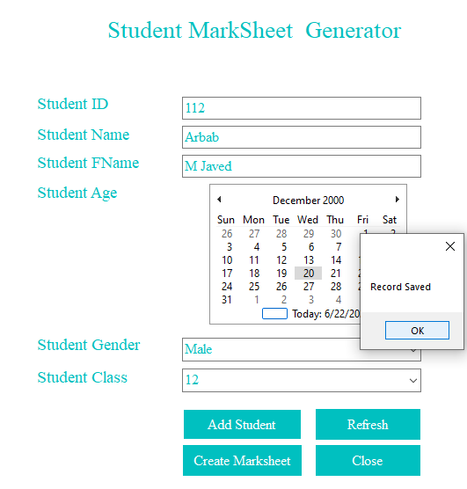

private void button1_Click(object sender, EventArgs e)

{

MessageBox.Show("Record Saved");

}

private void button2_Click(object sender, EventArgs e)

{

textBox1.Text = "";

textBox2.Text = "";

textBox3.Text = "";

}

private void button5_Click(object sender, EventArgs e)

{

this.Close();

}

private void button3_Click(object sender, EventArgs e)

{

Sheet sht = new Sheet();

sht.Show();

this.Hide();

}

private void button5_Click(object sender, EventArgs e)

{

Form1 srm = new Form1();

this.Hide();

srm.Show();

}

private void button1_Click(object sender, EventArgs e)

{

double total = double.Parse(textBox2.Text) + double.Parse(textBox4.Text) + double.Parse(textBox6.Text) + double.Parse(textBox7.Text) + double.Parse(textBox10.Text) + double.Parse(textBox11.Text);

label22.Text = total.ToString();

double totalmarks = 600;

double percentage = (total*100)/ totalmarks;

if (percentage>=80)

{

label26.Text = "A+";

}

else if(percentage >= 70 && percentage<80)

{

label26.Text = "A";

}

else if (percentage >= 60 && percentage < 70)

{

label26.Text = "B";

}

else if (percentage >= 50 && percentage < 60)

{

label26.Text = "C";

}

else if (percentage >= 40 && percentage < 50)

{

label26.Text = "D";

}

else if ( percentage < 40)

{

label26.Text = "Fail";

}

}

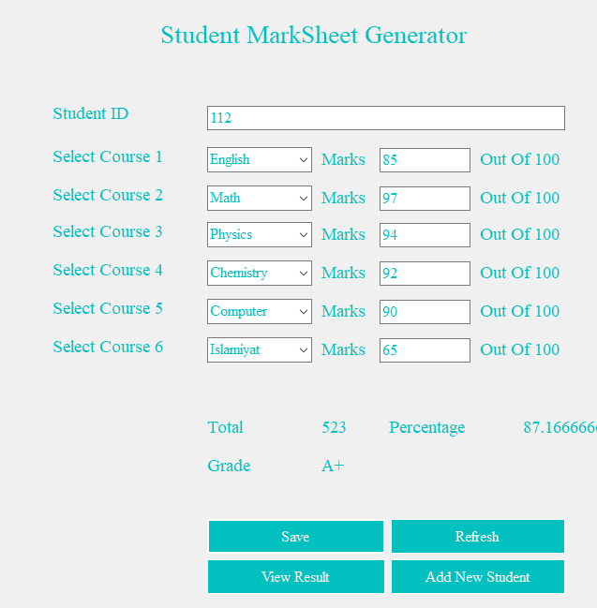

using System;

using System.Collections.Generic;

using System.ComponentModel;

using System.Data;

using System.Drawing;

using System.Linq;

using System.Text;

using System.Threading.Tasks;

using System.Windows.Forms;

namespace Marksheet

{

public partial class Sheet : Form

{

public Sheet()

{

InitializeComponent();

}

private void label7_Click(object sender, EventArgs e)

{

}

private void button5_Click(object sender, EventArgs e)

{

Form1 srm = new Form1();

this.Hide();

srm.Show();

}

private void button1_Click(object sender, EventArgs e)

{

double total = double.Parse(textBox2.Text) + double.Parse(textBox4.Text) + double.Parse(textBox6.Text) + double.Parse(textBox7.Text) + double.Parse(textBox10.Text) + double.Parse(textBox11.Text);

label22.Text = total.ToString();

double totalmarks = 600;

double percentage = (total*100)/ totalmarks;

label24.Text = percentage.ToString();

if (percentage>=80)

{

label26.Text = "A+";

}

else if(percentage >= 70 && percentage<80)

{

label26.Text = "A";

}

else if (percentage >= 60 && percentage < 70)

{

label26.Text = "B";

}

else if (percentage >= 50 && percentage < 60)

{

label26.Text = "C";

}

else if (percentage >= 40 && percentage < 50)

{

label26.Text = "D";

}

else if ( percentage < 40)

{

label26.Text = "Fail";

}

}

}

}

**Business Logic Layer:**

using Task1.DataAccessLayer;

using System;

using System.Collections.Generic;

using System.Linq;

using System.Text;

using System.Threading.Tasks;

using SDAAssignment2.Model;

using System.Windows.Forms;

namespace Task1.BusinessLogicLayer

{

public class BusinessLogicClass

{

Users users;

DataAccessClass dataAccessClass;

public BusinessLogicClass()

{

dataAccessClass = new DataAccessClass();

users = new Users();

public int View MarksheetData(String username, String StudentID)

{

users.UserName = username; users.StudentID = StudentID;

String query = "Select UserName, StudentID from customtab where UserName= '" + users.UserName + "' and StudentID='" + users.StudentID + "'";

if (dataAccessClass.loginForm(query) == 0)

{

MessageBox.Show("Error has occured");

return 0;

}

else

{

return 1;

}

}

public void InsertMarksheetRecord(String StdId, String Course1, String Course2, String Course3, String Course4,String Course5, String Course6, String total, String Perc, String Grade)

{

String Query = "insert into StdMarks(StdID ,course1, course2, course3 ,course4,course5,course6,total,percentage,grade) values('" + textBox2.Text + "','" + textBox4.Text + "','" + textBox6.Text + "','" + textBox7.Text + "','" + textBox10.Text + "','" + textBox11.Text + "','" + label22.Text + "','" + label24.Text + "','" + label26.Text + "')";

dataAccessClass.DataManipulationOperation(Query);

}

public void StudentData(String StdId, String Name, String Fname, String Age, String Gender, String Class)

{

String Query = "insert into Student(StdID ,Name, Fname, Age ,Gender,Class) values('" + textBox1.Text + "','" + textBox2.Text + "','" + textBox3.Text + "','" + monthCalendar1.Text + "','" + comboBox1.Text + "','" + comboBox2.Text + "')";

dataAccessClass.DataManipulationOperation(Query);

}

}

}

**Data Access Layer:**

using System;

using System.Collections.Generic;

using System.Linq;

using System.Text;

using System.Threading.Tasks;

using System.Data;

using System.Data.SqlClient;

using SDAAssignment2.Model;

using System.Windows.Forms;

namespace SDAAssignment2.DataAccessLayer

{

public class DataAccessClass

{

SqlConnection conn;

SqlCommand cmd;

SqlDataAdapter sda;

DataTable dt;

Users users;

public DataAccessClass()

{

string connectionString = @"Data Source=DESKTOP-UA4FIBG\SQLEXPRESS;Initial Catalog=Multilayeredmdf;Integrated Security=True";

conn = new SqlConnection(connectionString);

users = new Users();

}

public bool DataManipulationOperation(string query)

{

conn.Open();

cmd = new SqlCommand(query, conn);

int count = cmd.ExecuteNonQuery();

if (count > 0)

{

conn.Close();

return true;

}

conn.Close();

return false;

}

public DataTable DataNavigationOperations(string query)

{

cmd = new SqlCommand(query, conn);

sda = new SqlDataAdapter(cmd);

dt = new DataTable();

sda.Fill(dt);

if (dt.Rows != null)

{

return dt;

}

return null;

}

public int loginForm(String query)

{

int count = 0;

conn.Open();

cmd = new SqlCommand(query, conn);

cmd.Connection = conn;

cmd.CommandText = query;

SqlDataReader reader = cmd.ExecuteReader();

while (reader.Read())

{

count = count + 1;

}

if (count == 1)

{

conn.Close();

return 1;

}

else

{

conn.Close();

return 0;

}

}

}

}

